OPSC6312
OPEN SOURCE CODING (INTERMEDIATE)
PART 1
RESEARCH, PLANNING AND DESIGN

POKÉMON EXPLORER
Group Members: | 1: Keabetswe Ramahlape Malwa – ST10442089  2: Seabelo Motloung - ST10447004  3: Sheketli Mochaki - ST10452756  4: Gladwin Engetani Nkuna – ST10438545  5: Mothoka Malatji - ST10439690
Assessment Type | Group Project - Part 1
Module | OPSC6312 - Open Source Coding (Intermediate)
Institution | The IIE / Rosebank College
Submission Date | 24 August 2026

SECTION A - RESEARCH

1. Introduction
The objective of the research phase is to examine Android applications that solve problems like the proposed Pokémon Explorer application. The research focuses on dataDex, PokéCardex and Pokémon HOME because each application demonstrates a different approach to presenting, organising or managing Pokémon-related information.
The proposed application will use PokéAPI, an open RESTful data service containing Pokémon game data. PokéAPI exposes Pokémon resources such as identifiers, names, height, weight, abilities, moves, sprites, statistics, species and types (PokéAPI, 2026). The research is therefore used to determine which user-experience patterns should be adopted, simplified or avoided in our own application.
- dataDex - detailed Pokédex and game-data reference.
- PokéCardex - collection management and progress tracking for Pokémon cards.
- Pokémon HOME - official cloud storage, trading and National Pokédex experience.

2. dataDex - Pokédex for Pokémon
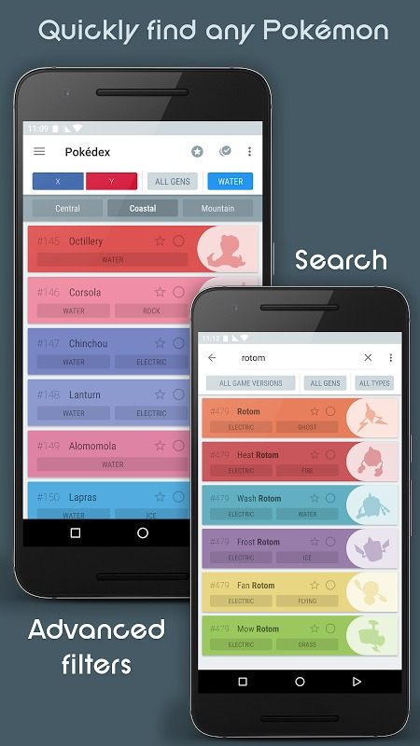
Figure 1: dataDex search and filter interface. Source: Aptoide app listing (2026).

2.1 Overview
dataDex is an unofficial Pokédex application by talZz. Its Google Play listing describes detailed data for Pokémon across the main series games, with searching, sorting and filtering by game version, generation and type. It also includes dedicated Pokédex, Move Dex, Ability Dex, Item Dex, Type Dex and Nature Dex functions. The application supports offline use, favourites and a caught checklist, while its Team Builder is presented as a PRO feature (talZz, 2026).

2.2 Strengths
- Broad Pokémon data coverage in a single application.
- Strong search, sort and filter controls for quickly narrowing large datasets.
- Offline access, reducing dependency on a constant network connection.
- Favourites and caught tracking create a personalised collection experience.
- Type information and weaknesses/resistances are useful for battle-oriented users.
- Team Builder adds depth for advanced users without changing the basic Pokédex purpose.

2.3 Weaknesses
- The amount of information can be intimidating to casual or first-time users.
- Some advanced functionality is placed behind the PRO purchase.
- The Google Play listing states that the application contains advertisements and in-app purchases.
- A large number of specialised “Dex” areas increases navigation complexity.
- Because it supports many game versions and data categories, the interface has to accommodate more detail than our proposed app requires.

2.4 How we think it was implemented
The dataDex source code is not publicly available, so the following is an informed Android-development assumption. A modern implementation could use a list/grid component such as a Jetpack Compose LazyColumn/LazyVerticalGrid or RecyclerView, a ViewModel to manage state, and a repository to isolate the UI from its data sources. Because the application advertises offline operation, a local database or packaged/cached dataset is likely to play an important role. In our own implementation, the equivalent responsibility will be handled with Room for structured local data and caching.
A possible internal flow is: UI -> ViewModel -> Repository -> local data source / online data source. This aligns with Android guidance that separates the UI layer from the data layer and uses repositories to centralise access to data (Google, 2026a).

3. PokéCardex
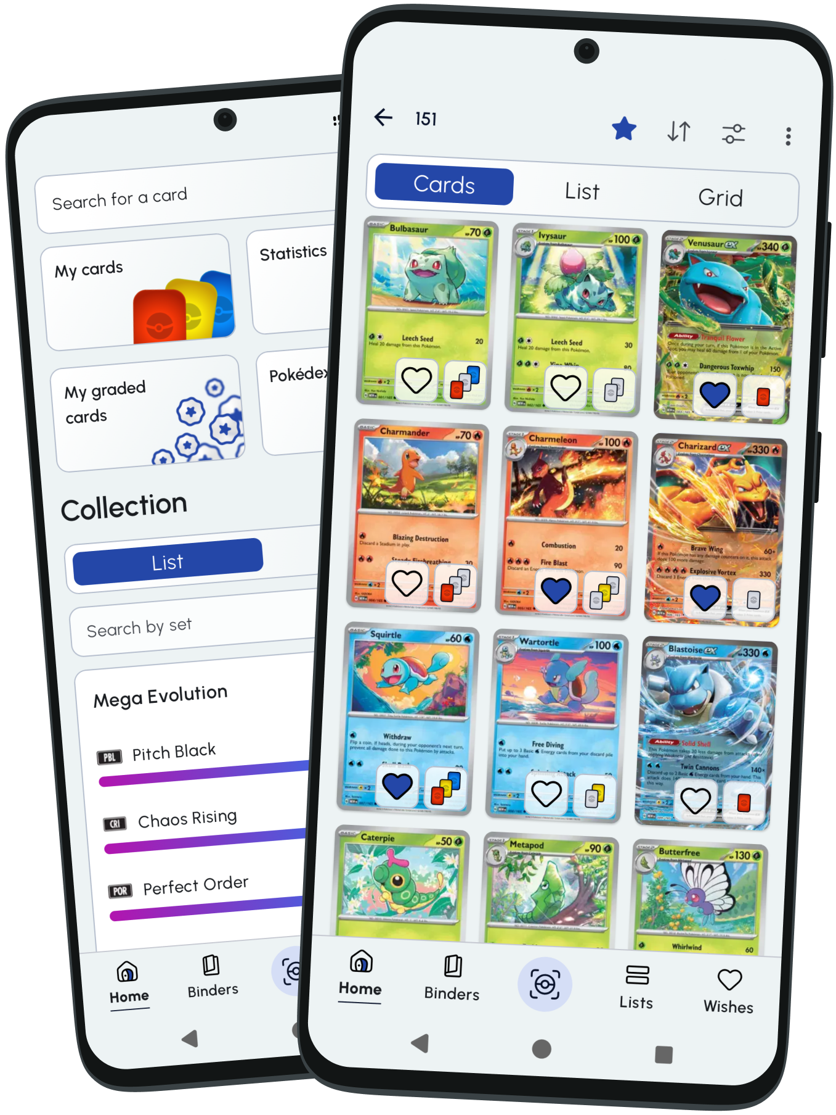
Figure 2: PokéCardex collection and grid interface. Source: PokéCardex official app page (2026).

3.1 Overview
PokéCardex is an Android Pokémon Trading Card Game collection manager from Numelek. Its current Google Play listing states that users can browse more than 23,000 cards across more than 230 series, manage collection details such as version, condition, quantity and language, view prices and price history, use a camera-based card scanner, create custom binders, view collection statistics, back up/synchronise a collection and use the application offline. Scanner and binder usage is unlimited only for PokéCardex Plus subscribers (Numelek, 2026).

3.2 Strengths
- Strong collection-management model with detailed ownership information.
- Collection statistics make progress visible and rewarding.
- Camera scanner reduces the effort required to locate a card manually.
- Custom binders provide flexible organisation.
- Offline access is useful for collectors who may not always have connectivity.
- Optional account synchronisation protects user-created collection data.
- Grid-based presentation works well for visually rich collectible content.

3.3 Weaknesses
- Its primary focus is trading cards rather than Pokémon species, so much of its data model does not map directly to a Pokédex.
- Some useful scanner/binder functionality is tied to a subscription.
- Collection, prices, marketplace data, sealed products and binders can make the experience broader than a simple explorer needs.
- User reviews on the current listing mention requests for greater interface customisation and some localisation/performance improvements.
- Price and investment information would be out of scope for Pokémon Explorer.

3.4 How we think it was implemented
PokéCardex does not expose its Android source code, so this section is also an informed technical interpretation. A local Room/SQLite-style database could support the offline collection, while a remote service could provide card metadata, prices and synchronisation. The scanner could use the Android camera through CameraX and then pass an image to a recognition/matching service. A repository would coordinate local collection state and remote content, while WorkManager could be suitable for deferred synchronisation when connectivity returns.
The most relevant idea for Pokémon Explorer is not the scanner itself, but the combination of local user state, progress tracking and fast grid browsing.

4. Pokémon HOME
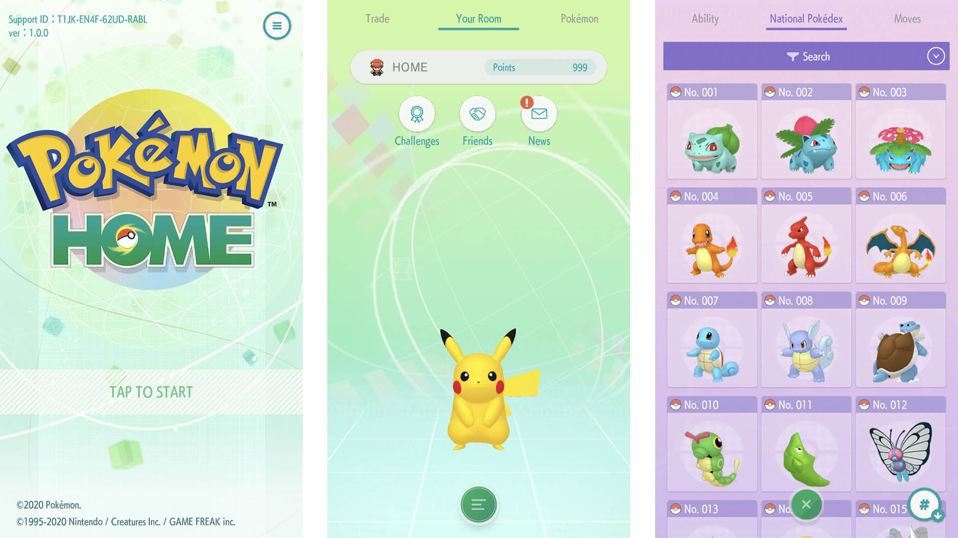
Figure 3: Pokémon HOME mobile interface. Source: Android Authority (2020).

4.1 Overview
Pokémon HOME is an official cloud-based service from The Pokémon Company. The Google Play listing describes it as a place where Pokémon can gather, with the ability to move compatible Pokémon between supported games, trade with other players, complete the National Pokédex and check moves and abilities. The official website further describes storage, trading and a paid Premium Plan with expanded limits (The Pokémon Company, 2026a; 2026b).

4.2 Strengths
- Official connection to the wider Pokémon ecosystem.
- National Pokédex functionality gives users a structured overview of their collection.
- Cloud storage allows Pokémon to be managed across compatible services and games.
- Multiple trading methods create a strong social component.
- The interface gives Pokémon imagery and profile information high visual priority.
- Cross-platform account linkage provides continuity between Nintendo Switch and mobile use.

4.3 Weaknesses
- Cloud storage and trading require significantly more backend infrastructure than a learning project needs.
- The experience is strongly network- and account-dependent.
- The paid Premium Plan increases limits and unlocks some functions.
- Trading, game transfers, mystery gifts and cloud management make the product more complex than a simple information explorer.
- Its goal is ecosystem management, whereas our app should prioritise quick discovery and readable information.

4.4 How we think it was implemented
Pokémon HOME is a commercial platform and its internal architecture is not publicly documented. Based on its observable functions, it would require secure authentication, cloud databases, server-side validation and services that coordinate accounts, storage, supported games and trading. The Android client would present information and send authenticated requests to backend services. This architecture is far beyond what Pokémon Explorer requires, but the polished profile presentation and collection structure are useful design references.

5. Comparative analysis
Feature | dataDex | PokéCardex | Pokémon HOME | Design decision
Primary focus | Species/game reference | Trading-card collection | Cloud Pokémon ecosystem | Focused Pokédex + personal tracker
Search and browse | Excellent | Excellent | Good | Adopt fast search and Pokédex-order browse
Filtering | Game, generation, type | Set, card, collection | Limited for this use | Adopt type and generation filters
Detailed profiles | Very detailed | Card-specific | Polished species profiles | Show essential information first
Offline operation | Yes | Yes | Primarily online | Room cache + reconnect refresh
Favourites / tracking | Favourites and caught | Excellent collection tools | National Pokédex tracking | Authenticated personal Pokédex
Account continuity | Not a main focus | Optional sync | Core account service | Mandatory secure registration/login
Multilingual UI | Multiple languages | Language options | Multiple regions/languages | English and isiZulu resources
GPS catch record | Not core | Not relevant | Not core | Opportunity required by brief
Push notifications | Not core | Service updates possible | News/service alerts | FCM real-time alerts
Cloud synchronisation | Not primary | Optional | Core service | Only reconnect cache refresh in Part 2
Trading / marketplace | No | Prices but no creature trading | Yes | Out of scope
Comparison | Not core | No | No | Innovative side-by-side feature
Random discovery | Not core | No | No | Innovative exploration feature
Overall relevance | Very high | Medium | High | Combine strengths without product sprawl

5.1 Best features selected for the final app
Research source | Feature / gap | How Pokémon Explorer will use it and why
dataDex | Search and filtering | Search by name/ID and filter by type and generation because large datasets need fast narrowing.
dataDex | Detailed profile | Present artwork, types, statistics, abilities, height and weight in a readable hierarchy.
dataDex | Favourites / caught | Persist personalised state for the logged-in user rather than keeping a generic checklist.
PokéCardex | Collection progress | Show caught progress and a visual collection grid to make progress motivating.
PokéCardex | Offline-first thinking | Cache viewed Pokémon and keep collection actions available without a network connection.
Pokémon HOME | Profile presentation | Use large artwork and clear hierarchy without copying its cloud-heavy scope.
Pokémon HOME | Account continuity | Use mandatory registration/login with protected credentials and user-owned records.
Assessment brief | GPS catch location | Optionally save current coordinates when a Pokémon is marked caught; denial does not block the app.
Assessment brief | Reconnect synchronisation | WorkManager refreshes stale cached Pokémon after connectivity returns while preserving local actions.
Assessment brief | Real-time notifications | Use Firebase Cloud Messaging for opted-in app alerts and updates.
Assessment brief | Two languages | Provide English and isiZulu resources selectable in Settings.
Identified gap | Side-by-side comparison | Compare six base statistics on one screen instead of repeatedly switching profiles.
Identified gap | Random discovery | Open a valid random Pokémon to encourage exploration.
Identified gap | Shiny toggle | Switch between normal and shiny artwork where PokéAPI provides both.
Controlled scope | Achievable Part 2 | Exclude trading, marketplace, card pricing and game transfers while retaining every mandatory brief feature.

6. Conclusion
The research shows that successful Pokémon applications make large datasets manageable through strong search, visual hierarchy and personal collection features. dataDex is the closest functional reference because of its Pokédex focus; PokéCardex contributes ideas about progress tracking, grids and offline collection state; Pokémon HOME demonstrates polished presentation and ecosystem-quality information organisation.
Pokémon Explorer will therefore use PokéAPI to deliver a focused discovery experience without reproducing the commercial scope of the three products. Trading, marketplace data, card pricing and game transfers remain excluded. However, secure registration/login, settings, optional GPS catch-location capture, offline use with reconnect synchronisation, real-time push notifications, and English/isiZulu support are retained because they are mandatory Part 2 requirements.
These findings directly guide the Planning and Design report: the selected features appear in the requirements table, screen flows, Room data model, architecture diagrams, technology stack, Gantt schedule and test plan. This traceability keeps the proposed design both innovative and assessable.

7. References
Numelek (2026) PokéCardex - Apps on Google Play. Updated 13 August 2026. https://play.google.com/store/apps/details?id=com.application.pokecardex
PokéAPI (2026) PokéAPI v2 Documentation. https://pokeapi.co/docs/v2
talZz (2026) dataDex - Pokédex for Pokémon - Apps on Google Play. Updated 22 June 2026. https://play.google.com/store/apps/details?id=com.talzz.datadex
The Pokémon Company (2026a) Pokémon HOME - official website. https://home.pokemon.com/
The Pokémon Company (2026b) Pokémon HOME - Apps on Google Play. https://play.google.com/store/apps/details?id=jp.pokemon.pokemonhome

Android Authority (2020) Pokémon HOME app interface screenshot. https://www.androidauthority.com/best-pokemon-apps-android-1088860/ (Accessed 24 August 2026).
Aptoide (2026) dataDex - Pokédex for Pokémon: app screenshots. https://datadex.br.aptoide.com/app (Accessed 24 August 2026).
Google (2026a) Guide to app architecture. Android Developers. https://developer.android.com/topic/architecture (Accessed 24 August 2026).
Google (2026b) Build an offline-first app. Android Developers. https://developer.android.com/topic/architecture/data-layer/offline-first (Accessed 24 August 2026).
PokéCardex (2026) PokéCardex Android and iOS application. https://www.pokecardex.com/app (Accessed 24 August 2026).

